Osmosis and the Case of the Sad Salad

Imagine opening up the refrigerator to take out carrots, lettuce, tomatoes, cucumbers, and other vegetables in order to prepare a delicious, crisp salad for your family’s dinner. You rinse off the vegetables, slice them up, place them in a big bowl, and lightly season them with salt, pepper, and salad dressing. Finally, you place the bowl of salad in the refrigerator, finish some homework, and listen to a few CDs until it is time to eat. At dinner, as you prepare to enjoy your crunchy creation, you suddenly realize that your once delicious-looking salad isn’t so desirable anymore – the carrots feel like rubber, the cucumbers are dry and limp, and the lettuce is wilted. What has happened to your salad?
Wilting houseplants, rubbery carrots, and limp lettuce all illustrate the same important biological principle—osmosis, the diffusion of water. In this activity, you’ll investigate how the process of osmosis affects plant cells, and learn some ways to prevent a sad salad.

Procedure:

- Fill two same size beakers half full of distilled water.
- Add 7g salt to one beaker, stir thoroughly, and label it “salt water”.
- Label the other beaker “distilled water”. Put group’s initials on each label.
- Get two similar size carrots. Tie thread tightly around each carrot. Make sure thread is tight.
- Put one carrot in each beaker.
- Allow beakers to stand undisturbed for 24 hours.
- Next class period, remove carrot sticks and observe.

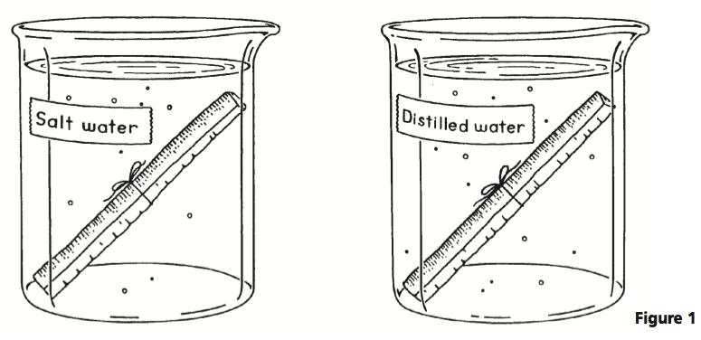
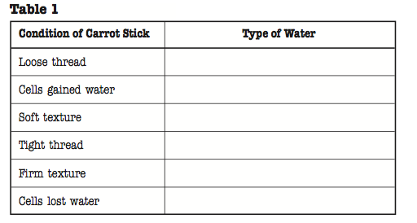

Analyze and Conclude

1. What was the purpose of tying thread around each carrot stick?

_____________________________________________________________________________________

_____________________________________________________________________________________

2. Using your knowledge of osmosis, draw a diagram to show what happened to the cells of the carrots in
this experiment. Use arrows and labels to help you.

3. A good way to prevent a sad salad is to always keep vegetables covered with plastic wrap, rather than
exposing them to the air. Use your knowledge of osmosis to explain why this method works.

_____________________________________________________________________________________

_____________________________________________________________________________________

4. Supermarket workers spray fruits and vegetables with water to make them more desirable to consumers.
Why does spraying vegetables with water prevent them from drying out?

_____________________________________________________________________________________

_____________________________________________________________________________________

